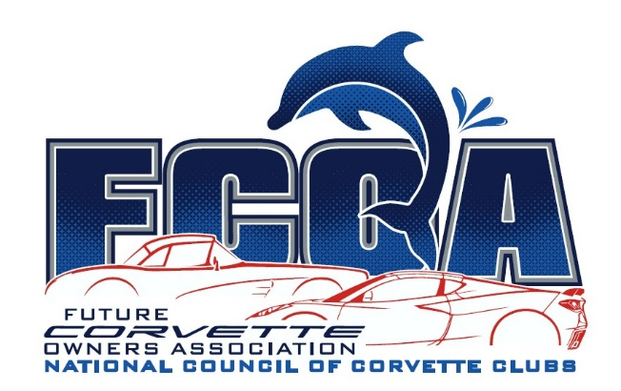

__________, 2025

Dear ___________,

Welcome and Congratulations on becoming a member of the Future Corvette Owners Association! Your grandparents, _______________, sponsored you for this club that is just for kids. Your FCOA Membership is the first step in what can become a lifetime of fun and friendship with others who share a passion for Corvettes just like you. You will stay a FCOA Member until your 16th birthday, at which time you can join NCCC as a Youth Member.

Every Corvette holds an important place in Corvette history. The fifth generation of the Corvette, also known as the C5, was introduced in 1997 and was in production until 2004. It featured a more refined and aerodynamic design and was available in both coupe and convertible body styles. The Z06 was the incredibly fast must-have version. Even today, the Z06 is much loved by enthusiasts, and many claim it is the best Corvette of them all. Don’t forget to Save the Wave by waving to other Corvettes when you’re riding in your grandparents’ 2000 C5 Convertible.

Enclosed are your FCOA patch and membership card, similar to what your grandparents have. Your FCOA Membership Number is _____. There are a lot of exciting things planned for this growing part of the National Council of Corvette Clubs, so please keep your contact information current to receive those updates. I hope you enjoy your Welcome Packet!


Save the Wave,

Melissa
FCOA Director
fcoadirector@corvettesnccc.org

2025 FCOA Sponsors

